Autumn/winter vaccination communications toolkit – for Care Homes

- Context
- The NHS is offering the flu and COVID-19 vaccines to those most at risk this autumn to top up their protection against these viruses.​ This includes all residents in care homes for older adults.
- ​Vaccination is the best way we can keep our most vulnerable communities well and reduce the risk of them needing hospital care if they do catch either virus.
- Please use the resources below to promote the vaccine offer in your care home.
- If you have any questions or need extra resources, email: communications@selondonics.nhs.uk

- Bulletin copy aimed at family members

Autumn vaccinations for residents
We’ll be offering flu and COVID-19 vaccines to residents this autumn to top up their protection against these viruses. Vaccination is the best way we can keep residents well and reduce the risk of them needing hospital care if they do catch either virus. Speak to your loved one about giving consent. Our team are here if you’d like any more information (or alternative call to action to suit your care home).

- Resources

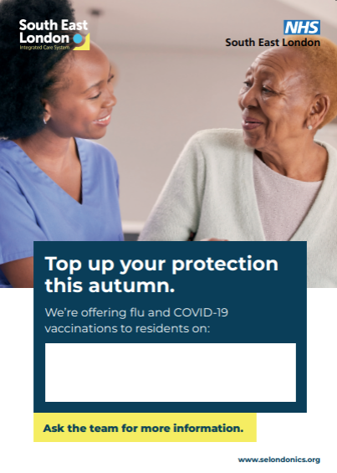 | Open belly poster to display vaccination visit times. To be printed out in your care home. If you need support with printing email: communications@selondonics.nhs.uk
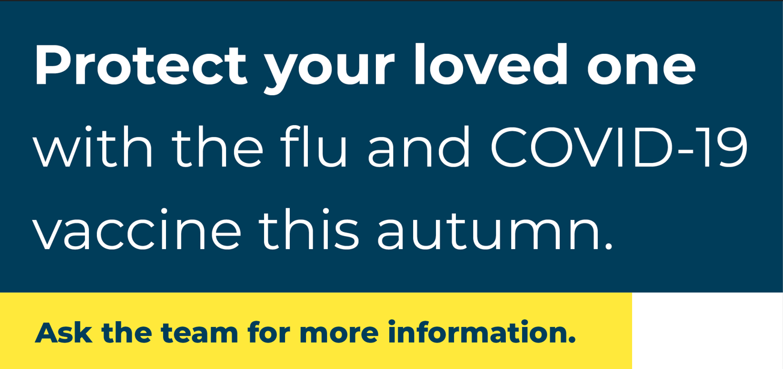 | Email signature  - Go into Outlook and click File > Options (on bottom left) > Mail > Signatures  - Click the signature you want to edit and make your changes in the ‘edit signature’ box.  - Ensure you have saved the image to your files. Click the ‘insert picture’ icon, locate the saved image and click ‘insert’.  - Right click on the image and select ‘add link’ and insert: www.nhs.uk/vaccinations/covid-19-vaccine/  - When you're done, select Save > OK.
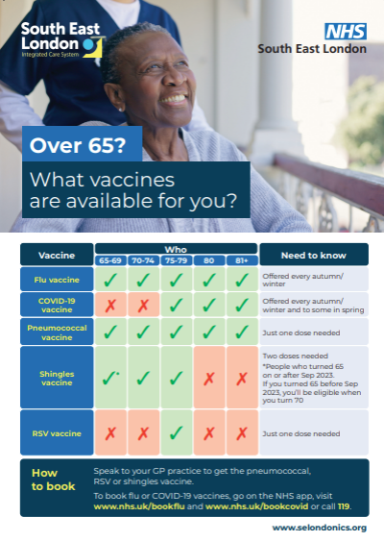 | Leaflet and poster on vaccinations for over 65s. To be printed out in your care home. If you need support with printing email: communications@selondonics.nhs.uk

- FAQs

Why does my family member/do I need another vaccination when I had one last year?
Like some other vaccines, levels of protection may decline over time. These viruses can also change each year. Vaccinations are being offered to residents this autumn to help them to maintain strong protection from becoming seriously ill or needing to go to hospital if they catch flu or COVID-19.

Can I get vaccinated if I feel unwell, or if I’ve recently had flu, COVID-19 or symptoms?
Wait until you’ve recovered to have your vaccine, but you should try to have it as soon as possible. You should not go to an appointment if you have a fever or think you might be infectious to others. If you have recently recovered, there is no need to delay getting vaccinated.

Can I get vaccinated if I’m taking antibiotics?
Yes, there is no interaction between antibiotics and these vaccines. You should only delay vaccination if you currently have a bad fever or ‘febrile’ illness, such as the rapid onset of headaches, chills or muscle and joint pains. A cold or mild fever are not reasons to postpone getting the vaccine. If you have any concerns, speak to the healthcare professional at your appointment.

Can you still catch flu or COVID-19 after having the vaccines?
These vaccines will reduce the chance of you becoming severely unwell from flu or COVID-19. It can take up to 14 days for your body to build up some extra protection from the dose. Like all medicines, no vaccine is completely effective. Some people may still get flu or COVID-19 despite having a vaccination, but any infection should be less severe.

Is vaccination safe?
Vaccines are highly regulated products. There are checks at every stage in the development and manufacturing process. Like all medicines, vaccines can cause side effects. Most of these are mild and short-term, and not everyone gets them. These vaccines are being continuously monitored for safety– the benefits of the vaccines far outweigh any risk in most people. If you have any concerns, you can speak to the healthcare professional at your vaccination appointment.

