Improving the identification of people with a learning disability

There are a lot of patients with the specific diagnosis that contributes to a learning disability who are not currently on the LD register and therefore, annual health checks and STOMP reviews have never been offered to this vulnerable group of patients.
This guidance is to support SouthEast London general practices on identifying the potential missing patients so they can be added onto the register.
The relevant codes to add or remove patients from the register is in the last part of this guidance.
There are 3 options if you have EMIS.
Option 1
Ardens built in searches
Locating the Case Finder Searches
To access the searches, navigate to the Population Reporting module > Ardens Searches > 5.00 Contracts - QOF - Case Finders search folder > Learning disability

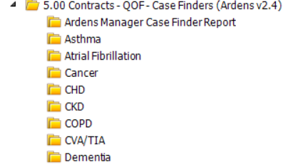
Notes: Please ensure Ardens is up to date otherwise the options will not show.
- Run the searches within the Learning Disability folder.
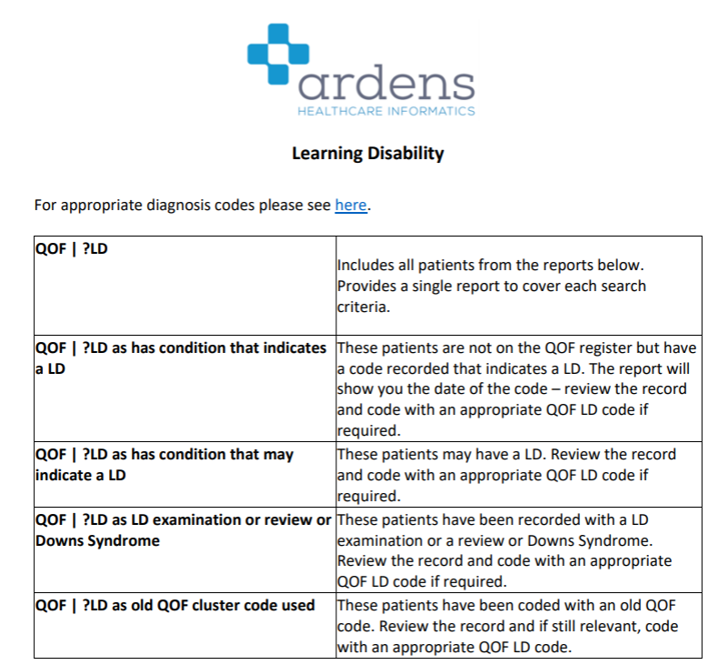

- ? LD as has condition that indicates a LD shows that the identified patients have a diagnosis (E.g., Noonan’s Syndrome, Down’s Syndrome) that indicates a learning disability, and they should be added on to LD register if they are not on it already.

Please see page 7-13 of appendix 1 for lists of LD codes and diagnosis for this cohort of patients.

- ? LD as has condition that MAY indicates LD shows additional review is required for this cohort of patients (E.g., Cerebral Palsy patients). They may have significantly reduced adaptive functioning (daily life activities such as buying milk and getting onto buses) and /or intellectual functioning (such as problem-solving and judgment) Please see Appendix 1 for more information to support practices on identifying LD eligibility.

Please see page 14-21 of Appendix 1 for lists of LD codes and diagnosis for this cohort of patients.

- When reviewing patient’s eligibility, please also consider their vulnerability, social impact, ability to communication and express concerns, the likelihood of patient having an unnecessary hospital admission, the likelihood of patient at risk of neglect if carer is no longer around. Etc

Option 2
EMIS internal searches
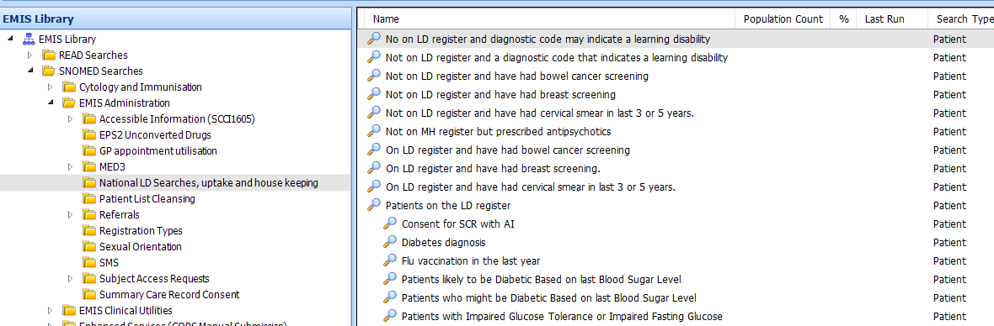
Notes: EMIS has to be up to date

Instruction:

- The EMIS library contains a folder in SNOMED Searches > EMIS Administration > National LD Searches, uptake, and housekeeping.

The 2 relevant built in searches as below:
- ’Not on LD register and diagnostic code that indicates a learning disability’
- Anyone identified on this list is recommended to go onto the register if they aren’t currently on it.

- ‘Not on LD register and diagnostic code that MAY indicate a learning disability’
This search is useful for identifying patients for possible inclusion on to the register. However, an additional review is required for this cohort of patient. Reduced intelligence or below average IQ (one of the criteria for learning disability) is not usually affected in this cohort of patients (E.g., Cerebral Palsy patients). Please see appendix 1 for more information to support practices on identifying LD eligibility.

Option 3
The South East London Learning Disability and Autism Specialist Prescribing Advisors from the SEL ICS

- This is facilitated via LDAprescribingTeam@selondonics.nhs.uk , email for more information.
- It requires an EMIS logon set up for one of the specialist prescribing advisors
- An EMIS remote dial in will be performed and a search will be run by the prescribing advisors
- An excel spreadsheet containing 3 cohorts will be populated:
- Patients with a diagnosis that WILL indicate a learning disability
- Patients with a diagnosis that MAY indicate a learning disability
- Patients who are currently on the Learning disability who might have been coding incorrectly (E.g., Learning difficulty, ADHD, Aspergers or high functioning autism)

General notes when reviewing an individual’s LD eligibility
Potential criteria: Vulnerable patient who have physical health needs and are at risk of neglect; frequent unnecessary hospital admission for preventable health issues E.g. (constipation)
Exclusion criteria: Passed GCSE, Passed DVLA or driving test / able to drive, graduated from a university with any degree, doing a high skilled job

Appendix 1
Improving identification of people with a learning disability: guidance for general practice (england.nhs.uk)
page 22 and onwards.
Adding patients onto EMIS LD register
- Use 'on learning disability register’ - EMIS code 918e or SNOWMED code 416075005

Removing patients from EMIS LD register
- You will have to go back to the FIRST ever learning disability code on the patient’s record timeline, right click on the code to either edit it or replacing it with another code, such as learning difficulty.
PS: The first code may have been added under problems and care history.
- PS Ensure checking patients have come off the register once you have adjusted the codes. If not, you may have to remove ALL old LD related codes on problems and care history.
- 