EMIS Web - National LD Health Check and Action Plan Protocol

The EMIS protocol entitled “National LD Health Check and Action Plan” is designed to be launched via the F12 Protocol Launcher and enables you to complete the “National Template for LD Annual Health Check” and print an Action Plan for the patient.

To Activate the “National LD Health Check and Action Plan” Protocol

In EMIS Web, open Resource Publisher (via the EMIS button and Configuration)

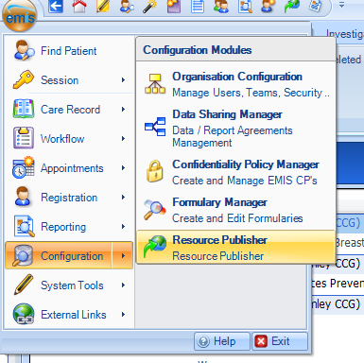

Click Protocols and Templates
Double click the EMIS library folder
Double click the EMIS Protocols folder
Double click the ES Protocols folder
Click “National Template for LD Health Check”
Check the status is Active
If the status is Inactive, click Activate

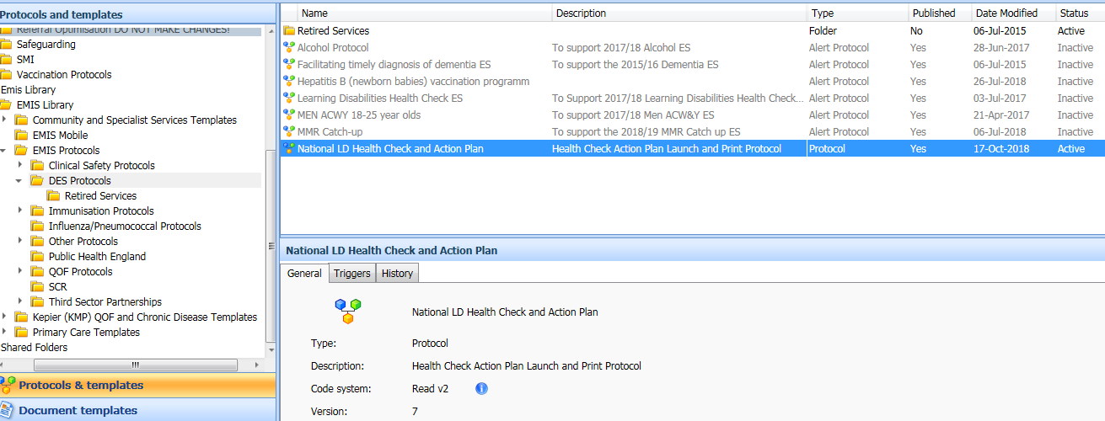

To Add the Protocol to the F12 Protocol Launcher (user specific)

Each user must add the “National LD Health Check and Action Plan” protocol to the F12 Protocol Launcher.
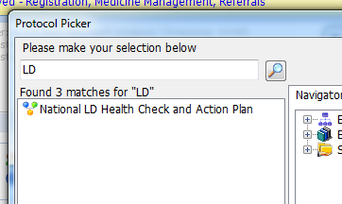
- Press F12
- Right click on a blank letter
- Select Add
- Type “LD” and click the magnifying glass
- Double click "National LD Health Check and Action Plan”
- The protocol is added to the users F12 Launcher

To Run the Protocol

In an active consultation, press F12 to launch the Protocol Launcher
Double click “National LD Health Check and Action Plan”
The “National Template for LD Annual Health Check” is launched

Complete the template as appropriate. Please note that there are 4 pages to complete;

- General Details
- Screening and Advice
- GP Assessment 1
- GP Assessment 2

Ensure that the Learning Disability Claim Section is completed where appropriate, and enter relevant text to be added to the care plan where indicated.

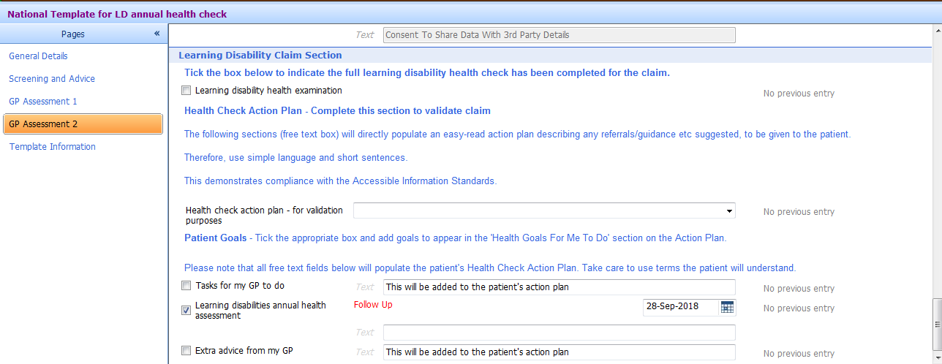

Ensure that “learning disabilities health action plan completed” is selected from the “Health check action plan – for validation purposes”

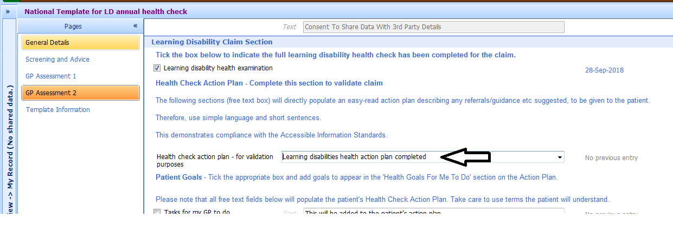

Important: Once the template is completed, click Save Template

Add any further details to the consultation as required and then click Save to save the consultation

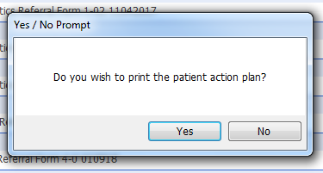

The care plan is launched. Make any additions/amendments as required.

Click File and Print. Once printed click File and Save and Close

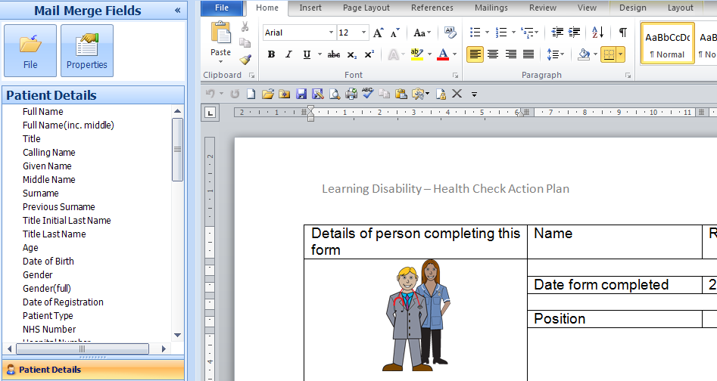

The care plan is saved to the patient record.
To Add a Patient Warning

You can use the patient précis to add, edit and remove patient warnings, and to specify when they are to be displayed. To add a warning (for example, “communication difficulties”):

Double click the Patient Precis (blue patient information bar) to expand.
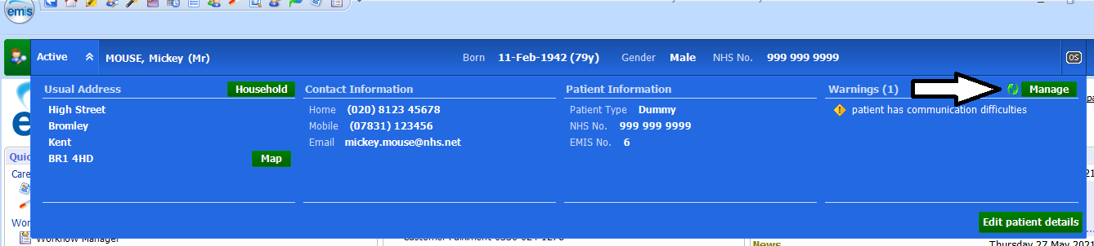

In the Warnings section, click Manage.
Click Add
In the Warning Message field on the Add Patient Warning screen, type the text of the warning.
In the Trigger Points section, select the action(s) that you want to trigger the warning.
Click OK.

Annual Health Check Invitation

It is recommended that practices use the following codes to record the invitation in the patient record.

- Learning disability annual health check verbal invitation 520821000000109
- Learning disability annual health check telephone invitation 520841000000102
- Learning disability annual health check letter invitation 521421000000100
  - Learning disability annual health check invitation 1st letter 712781000000107
  - Learning disability annual health check invitation 2nd letter 712801000000108
  - Learning disability annual health check invitation 3rd letter 712821000000104

Example Easy Read Resources

Annual_health_checks_Easy_Read_1.pdf (mencap.org.uk)

Easy read – A guide to your COVID-19 vaccination for people with a learning disability and their carers (publishing.service.gov.uk)

CSP05_an_easy_guide_to_cervical_screening.pdf (publishing.service.gov.uk)

Protect yourself from flu, have the flu vaccine (publishing.service.gov.uk)
Testicular cancer and self-checking [PDF, 4.34MB] (macmillan.org.uk)

NHS England » Summary Care Records

EMIS Library Searches

The EMIS library contains a folder in SNOMED Searches > EMIS Administration > National LD Searches, uptake and housekeeping. The search “Not on LD register and a diagnostic code that indicates a learning disability” is useful for identifying patients for possible inclusion on to the register.

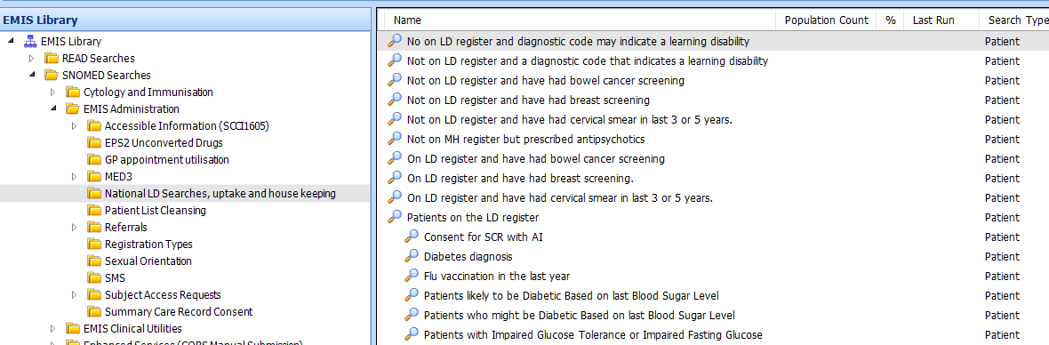

QOF – Learning Disability Register

The GP QOF Register can be found in Population Reporting > GP Contract – QOF > Clinical Indicators > Learning Disabilities

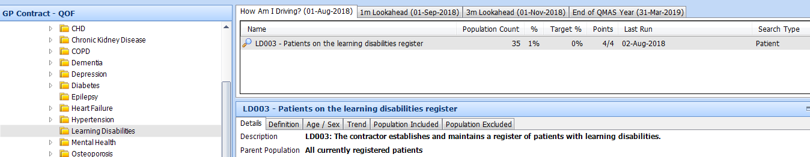

The following SNOMED will add the patient to the Learning Disability QOF register:

- On Learning Disability Register 416075005

