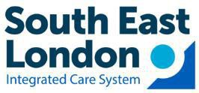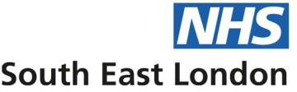
Board meeting in Public

Title | Development of our South East London Neighbourhood Health Service
Meeting date | 15 October 2025 |  | Agenda item Number | 11 | Paper Enclosure Ref | K
Author | Holly Eden, Director of Delivery – Neighbourhoods and Population Health
Executive lead | Holly Eden, Director of Delivery – Neighbourhoods and Population Health
Paper is for: | Update | x | Discussion |  | Decision | x
Purpose of paper | To receive the report from the Chief Executive Officer
Summary of main points | The attached presentation outlines the progress being made across South East London to develop our Neighbourhood Health Service, providing updates on delivery to date and planned activity against the five main deliverables reflected in the national Neighbourhoods approach:  - The Model Neighbourhood  - Model System Architypes  - Model Neighbourhood Health Centre Archetypes  - The National Framework for Neighbourhood Health Plans  - The National Neighbourhood Health Implementation Programme  - ​
Potential conflicts of Interest | None
Relevant to these boroughs | Bexley | x | Bromley | x | Lewisham | x
Relevant to these boroughs | Greenwich | x | Lambeth | x | Southwark | x
Equalities Impact | Neighbourhoods is expected to reduce health inequalities through proactive and preventative care models and integrated care delivery supported by population health approaches
Financial Impact | A cost and impact modelling workstream for the neighbourhood health service is in place initially focussing on Integrated Neighbourhood Teams
Public Patient Engagement | A range of public engagement exercises have been undertaken over the last 3 years which have contributed to the development of the SEL Neighbourhoods Programme. Local Care Partnerships will continued to engage with the public during the detailed development and implementation of their local neighbourhood plans.
Committee engagement | ICB Executive, Local Care Partnerships, Neighbourhood Based Care Board
Recommendation | It is recommended that the Board note progress across all areas.


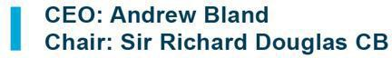
ICB 15 Oct 2025 Page 235 of 245



SEL ICB: Neighbourhoods Update
October 2025

ICB 15 Oct 2025 Page 236 of 245

National context
The National Neighbourhoods approach has been structured around five key deliverables for which there will be national guidance/ expectations that local systems will wish to respond to:
- Model Neighbourhood: to include the definition, scope and expected services within a neighbourhood, what is more likely to be coordinated across multiple neighbourhoods and how we see the leadership, planning and performance management of neighbourhoods evolving
- Model System Archetypes: to include how contracts can fit together in different archetypes of an overall system provider landscape
- Model Neighbourhood Health Centre Archetypes: to include the main archetypes and the supporting logic of what services should be ideally co-located together, depending on the
topography of a local community, and the approach ICBs can take to maximise their assets to support neighbourhood health.
- National Framework for Neighbourhood Health Plans: a joint NHSE/DHSC/LGA framework document to be published alongside NHS planning guidance which will cover the strategic element of local planning
- National Neighbourhood Health Implementation Programme: A national programme aims at accelerating work across places by learning together, sharing solutions, tackling challenges and delivering improvement
To support the ICB Board we have structured our Neighbourhoods update to align with this national structure:
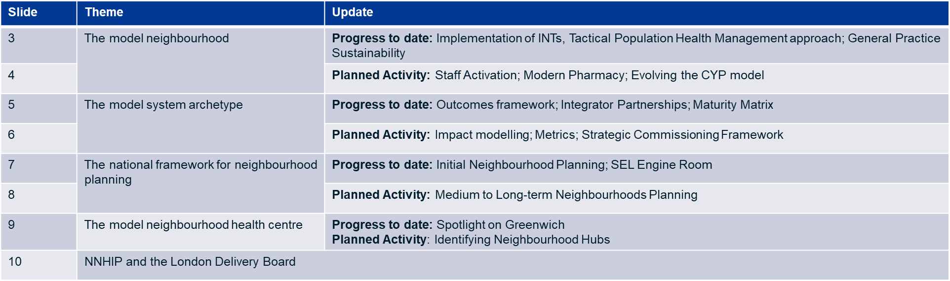

The "model neighbourhood”
Progress to Date

Implementation of INTs

  - Continued progress in the implementation of Integrated Neighbourhood Teams (INTs) for our three priority cohorts – multiple long-term conditions (mLTCs), frailty/ageing well, and children/young people (CYP).
  - Places are putting core enablers in place, including integrator governance and leadership groups, targeted recruitment and induction, estates readiness, and digital pathways with information governance and EMIS access.
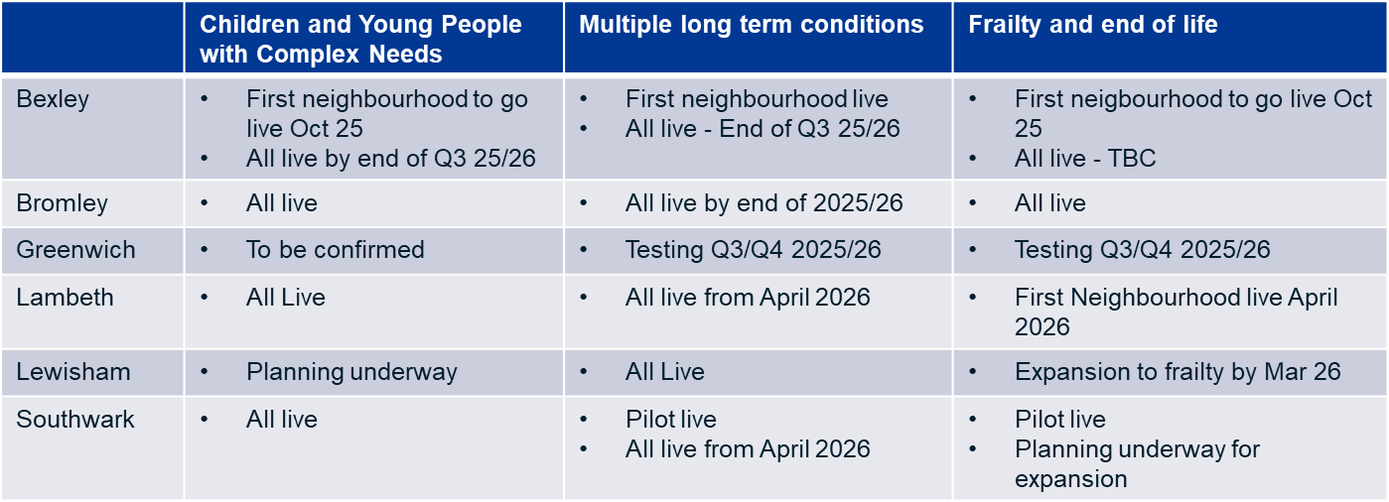

Tactical Population Health Management (PHM) approach
  - Introduction of new PHM capabilities for neighbourhood working via Ardens, whilst work remains ongoing on the future PHM function for the system.
- This includes universal access for general practice and Integrated Neighbourhood Teams (INTs) to tools to support identification and case management of our INT priority populations based on the Bridges to Health population segmentation approach.
- Also access to the Frimley segmentation model, which applies a RAG (red, amber, green) rating to people’s conditions and needs with real-time data tools that enable more efficient triage and streamlined flow across general practice

General Practice Sustainability: Co-developing a support offer

  - South East London has taken a co-designed, evidence-based approach to developing a refreshed GP support offer, ensuring it reflects both the realities of frontline general practice and system priorities, while recognising the central role of practices in neighbourhood health.
  - A focused Sprint process (Aug–Sept 2025) brought together frontline staff – GPs, nurses, practice managers and PC+ representatives – alongside SEL ICB colleagues, borough teams, training hubs and LMCs. This process combined local insight, national best practice and workforce intelligence to create an offer that is both practical and scalable.
  - The support offer has been signed off by the NBCB, providing a clear mandate for delivery and ongoing iteration with practices. A second Sprint in October, led by the PC Exec and PC+ Group, is now focusing on implementation and on how SEL ICB can adopt a more strategic commissioning approach, embedding collaboration with providers in the delivery of commissioned support.

The "model neighbourhood”
Planned Activity

Staff activation

Workforce and Communications workstreams have recently been collaborating on developing a staff activation plan which will be rolled out in this financial year. The aim is to activate and empower the workforce across SEL (particularly those working in INTs) so that they feel ownership of neighbourhood-based care, understand their role, are equipped with the knowledge and skills they need to lead local change, and have access to the training and support they need to develop.

Activation will adopt a phased approach:
  - Pre-activation baseline: Mapping each place’s readiness, staff groups affected, and INT progress.
  - Phase 1 - Awareness (6 months): Campaigns, FAQs, case studies, leadership endorsement.
  - Phase 2 - Educate and empower (12–18 months): Training, leadership development, digital literacy, learning forums.
  - Phase 3 - Enable and embed (18+ months): Ongoing staff forums, champions network, recognition, feedback loops.

Modern Community Pharmacy

  - Community Pharmacy South East London ( LPC) are collaborating with the ICB to develop a vision for modern community pharmacy as part of neighbourhood care.
  - This will develop a Modern Community Pharmacy document which can act as a strategic template to engage with community pharmacy around their role in neighbourhoods across four key care domains – preventative care, acute care, planned care and chronic care

Evolving the Children and Young People model

  - All places have made progress in implementing INTs to support children and young people with complex needs, based on the existing CHILDs model.
  - Work is now underway across South East London to collaborative design the evolution of this model into a broader neighbourhood model for children and young people, working closely with local authority colleagues to ensure this reflects the Family First ethos.
  - This is people jointly sponsored by the Babies, Children and Young People Strategic Partnership Board and the Neighbourhood Based Care Board and aims to report in Q4 25/26 for implementation within 26/27

The "model system archetype”
Progress to Date

The SEL Neighbourhoods Outcomes Framework

The SEL Neighbourhoods Working outcomes framework, presented to the ICB Board in July, was developed through engagement with colleagues from across the system, and aims to reflect the impact we anticipate for all partners and residents.

Crucially, this cannot stop with health; the impact will be felt across social care, the voluntary and community sector, and those working within the wider determinants – only with everyone in the system participating and realising this impact can the neighbourhood model achieve its holistic ambitions for transforming how we deliver services. This outcomes framework attempts to capture the full scope of this ambition reflected by neighbourhood working.

Integrator Partnerships

All six places across South East London have now established their integrator partnerships that bring together NHS trusts, primary care, social care and the VCSFE within a place, supported by a host organisation. Integrator Partnerships will drive forward Neighbourhood working and is a critically important preparatory phase for partners in each Place to ensure they are best placed to respond to future development and to make progress on Neighbourhood working.

The SEL Neighbourhood Maturity Matrix

A SEL Neighbourhood Maturity Matrix has been developed to help partnerships and their integrator host organisations understand how neighbourhood-based care develops over time. It sets out both functional domains (e.g. operational coordination, infrastructure, PHM) and relational domains (e.g. trust, partnerships, culture) that need to mature to enable effective neighbourhood working.

The maturity approach is intended to be supportive but not exhaustive. It is not a blueprint or specification. The intention is to:
  - Provide prompts that promote open discussion, debate and deep reflection within and across place partnership arrangements supported by host integrator organisations on what the role of local partners and the integrator host is in enabling neighbourhood health.
  - Enable local partners to reach a common view as to the current level of maturity of local functions; and
  - Jointly identify key developmental priorities

Each integrator is now being using the matrix to inform initial developmental priorities and ensure these are reflected in local plans This will also be reported into the ICB Board
for their continued oversight.

The "model system archetype”
Planned Activity

Impact Modelling
Milestone | Date
Finalise patient-level data request for acute, primary, and community care with SEL BI team | Sept 25
Agree approach and assumptions for financial model (acute, primary, community cost implications) | Sept 25
Start modelling using patient level data | Oct 25
Interim report summarising finalised approach, available data, and key assumptions | Nov 25
First run data analysis complete | Oct 25
First draft set of results shared for feedback with key stakeholders | Nov 25
Share final report including next steps to develop modelling approach, toolkit, and engagement with providers | Dec 25

The SEL BI team, Lewisham PHM team, and PPL are working as a blended team to develop what will be the most systematic attempt to model the impact of the shift to Neighbourhood working to-date, with an initial focus on the Frailty and Multiple LTC INTs.
The team built on the Theory of Change and Outcomes Framework to develop logic models setting out the mechanisms through which INTs are expected to impact the distribution of demand across the system and therefore the associated (theoretical) financial implications
The initial modelling exercise, whose timeline is set out on this slide, will produce an initial set of results on the impact of INT rollout on demand and the associated theoretical financial impact. The intention is to work with providers to build on the initial financial modelling to account for their real cost bases to inform discussions on funding flows and future contracting.
The core impact model and the associated dataset have a wide range of use cases beyond financial modelling, including workforce modelling, evaluating future business cases for neighbourhood working, and identifying opportunities for preventative care

Metrics
Building on the Outcomes Framework & Theory of Change, work is now taking place to identify key metrics associated with the initial priority cohorts to enable the effective measurement of impact/ benefits realisation. Once agreed, these metrics will inform the development of a dashboard that will support monitoring and reporting into the NBCB.

Strategic Commissioning
Work is underway to develop a strategic commissioning framework for neighbourhoods which aligns with the ICB’s Five Year Strategic Commissioning Plan and national policy development, particularly around model system archetypes. This work will consider how we shift towards population and outcomes-based commissioning approaches and maximise new financial incentives and contract forms that may emerge. The work will be developed in partnership with the ICB’s Strategic Commissioning Directorate and place leadership.

The "national framework for planning”
Progress to Date

Initial Neighbourhood Planning

All places in South East London have undertaken local planning to enable the delivery of Neighbourhood working. These plans reflect both local health improvement priorities identified with Joint Health and Wellbeing Strategies as well as system-wide priorities reflected in our Joint Forward Plan and our Neighbourhoods Framework. Planning to date has been focused predominantly on the 2025/26 financial year.

As part of the broader SEL Neighbourhood Programme there are six established enabling workstreams responsible for delivering the key tools and infrastructure required across the system to enable Neighbourhood working. Again, planning to date has been focused predominantly on the 2025/26 financial year.

The SEL Engine Room
Given the complexity and interdependencies of SEL's Neighbourhood programme, a central Engine Room has been established. The Engine Room acts as a programme management and coordination function at SEL level, providing oversight, aligning activities, facilitating shared learning, and maintaining momentum. It supports the Neighbourhood Based Care Board (NBCB) by synthesising information from workstreams and Places, escalating risks and issues, and ensuring decisions are informed by accurate and timely data.
The Engine Room also aims to increasingly foster a ‘test and learn’ culture, encouraging continuous improvement and iteration of models based on emerging evidence and local experience.

 | Workstream (sub-workstream)
1 | Delivery of INTs and Neighbourhoods | INT delivery
1 | Delivery of INTs and Neighbourhoods | Models of care for priority areas
2 | Population Health Management approach & data
3 | Flexible workforce models and culture change
4 | Comms and Engagement
5 | Strategic planning and resource allocation | Strategic commissioning
5 | Strategic planning and resource allocation | Estates
5 | Strategic planning and resource allocation | Modelling and impact
6 | Digital

NBCB Highlight reports
These aim to provide a valuable single point of clarity and visibility for both the Board and for Place and workstream leads. In a highly interconnected and changing programme context, this will support leads to maintain a view of all relevant activity, plan ahead and manage dependencies, and make connections across the
system.

The “national framework for planning”
Planned Activity

Medium to Long-term Neighbourhoods Planning
Delivering the shift to neighbourhood working requires a long-term approach and a complex and multi-faceted change programme with significant alignment between activities delivered and coordinated across places, providers, system and enabler functions.
Local Neighbourhood Plan(s)
- Part A: Population health improvement plan which includes social care, public health and BCF, co-ordinated by Health and Wellbeing Boards.
- Part B: Delivery plan for neighbourhood health services.
Five-year strategic commissioning plan
- Integrated plan that cover service plans, workforce, finance, quality improvement and digital.
- Will bring together local neighbourhood plans into a population health improvement plan (PHIP).
- Plan will include details on overarching population health and commissioning strategy, new models of care and investment programmes aligned to the 10 YP, how funding will be used to meet need/maximise value/deliver priorities, and how the ICB core capabilities will be delivered.
Our initial focus has been on establishing INTs for specific populations, but we need to widen this out to reflect the broader paradigm shift in how and where care is delivered, recognising the underpinning community assets, prevention and targeted interventions. We will also need to be ready to instigate work that has not yet come online but is signalled in the 10 year plan, such as genomics.
The development of our long-term road map for neighbourhoods within South East London will assist with and compliment the development of our broader planning requirements set out within the draft planning guidance issues in August 2025.

With this context in mind SEL is developing a system-wide roadmap that:
- Provides a common framework and language for neighbourhood
development and delivery against the 10 Year Plan.
- Shows clear alignment between and across local, regional, and national policy and implementation.
- Brings together related workstreams, such as digital, workforce, commissioning, and estates.
- Recognises that different places are at different levels of readiness and maturity.
- Supports sequencing of activity in line with national funding cycles and
procurement windows
- Gives visibility to workstream leads and wider partners, helping them plan ahead within a shared system framework.

Model neighbourhood health centre archetype

Progress to Date: Spotlight on Greenwich

Greenwich has recently explored how it can navigate the longstanding estate challenges it faces (limited capital investment, constrained capacity, complex approval processes) by rethinking how spaces can better support neighbourhood-based health and care, namely by identifying Neighbourhood hubs. The approach:

  - A Local Estates Forum is now in place, with members drawn from across the system. This is working alongside the GP Estates Strategy to guide transparent and system- wide decision making.
  - A structured process has been undertaken to explore challenges and build consensus around Neighbourhood Hub options – this involved a desk review, borough-wide workshops, and validation through the Estates Forum.
  - Hub preferred options have been identified for each of Greenwich’s four neighbourhood
clusters/geographies

Planned Activity – Delivering Neighbourhood Hubs

Across South East London, work is already underway at Place level to identify prospective neighbourhood hubs, supported by the SEL Estates workstream. Initial mapping activity is in progress, but further structured support is required to build a coherent and consistent view across the system.

The work planned for the next quarter includes:

  - Supporting Places to understand and explore the current challenges and opportunities around current estates.
  - Understanding available estates and agreeing which hubs to prioritise
  - Establishing what is needed to bring each hub into operation, including capital works, IT infrastructure, and other enablers, so that they are functional and able to support neighbourhood working.

Neighbourhood hub identification

To achieve this the Estates team is currently developing a support offer based on the recent Greenwich approach. This covers four key stages:

- Diagnostic – provide a light touch overview of the current position for each Place.
- Design a flexible engagement offer that meets each Place where it is at. It will include agreeing the shared principles of what is required from a neighbourhood hub, built from the 10 year plan, London TOM etc Drawing on the recent Greenwich example.
- Carry out the engagement – likely in the form of cross-system workshops and 1:1s.
- Mapping and consolidation – map the outputs from the engagement in a structured and consistent way.

Where do we hope to get to?

The consolidation activity aims to provide:

  - A clear view of the current status of hub identification across all six Places.
  - A comparison of where Places are aligned and where variation remains.
  - A system-wide picture of what is needed to progress the establishment of functional neighbourhood hubs, including enablers such as capital investment, IT infrastructure, and programme support.

NNHIP and the London Neighbourhood
Delivery Board

SEL is actively engaged in both the National Neighbourhood Health Implementation Programme (NNHIP) and the newly established London Neighbourhood Delivery Board. Together, these programmes represent a significant opportunity for SEL to accelerate neighbourhood working, influence national policy, and strengthen the infrastructure needed to deliver the 10-Year Health Plan through local, place-led action.
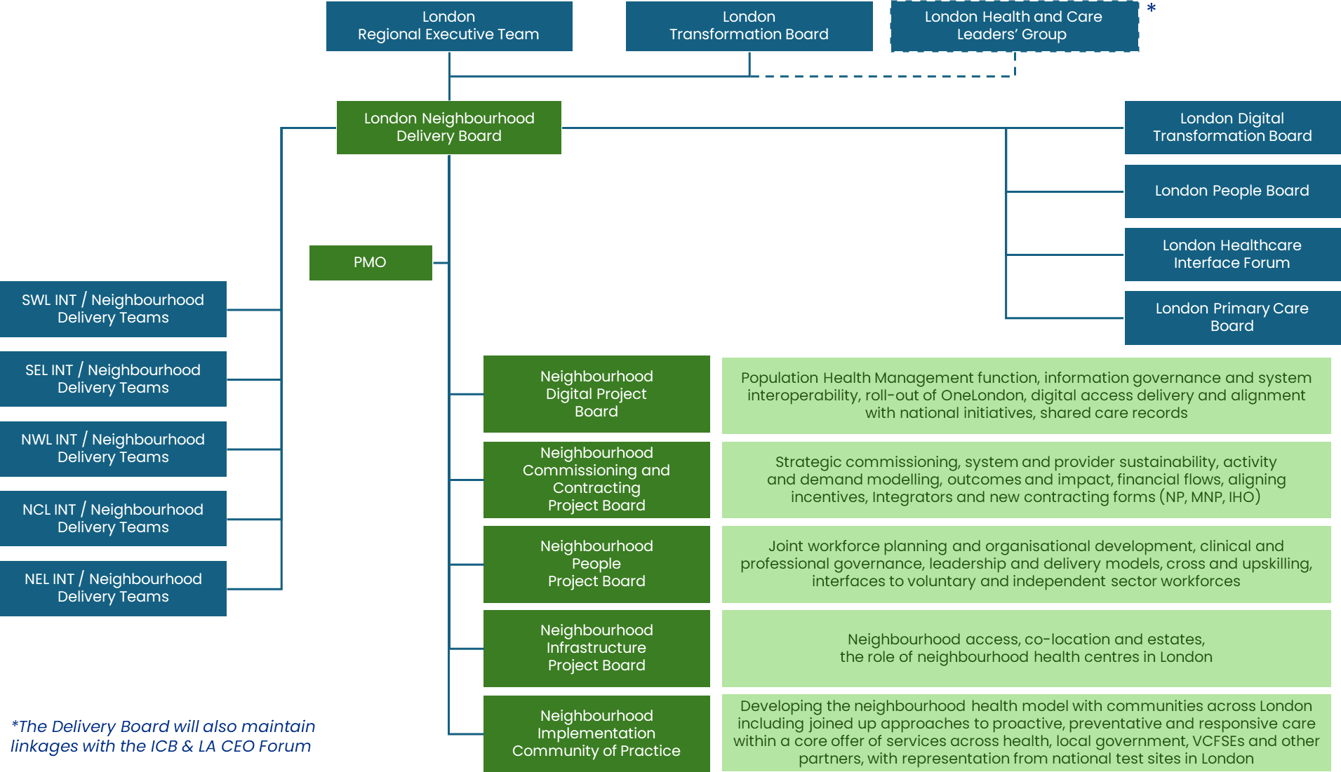
- The National Neighbourhood Health Implementation Programme (NNHIP) is supporting 43 Places across the UK to strengthen neighbourhood-based health and care.
- Southwark and Lambeth are part of Wave One, working with national and local coaches to test new approaches for people with long-term conditions and those at rising risk.
- The programme aims to accelerate integrated working, share learning rapidly, and influence national policy on key enablers such as funding and digital.
- The London Delivery Board coordinates neighbourhood implementation across the capital, grouping shared enablers into five project boards (Digital, Commissioning and Contracting, People, Infrastructure, and Implementation/Community of Practice).
- For SEL, this provides structured support while retaining flexibility to shape delivery locally. Early focus is on workforce development, digital interoperability, commissioning reform, and embedding shared learning across neighbourhoods.

