Greenwich Adult Dietetics (Malnutrition)

Food First Team Referral form
Patient Details
Surname: |  | Forename:
DOB: |  | NHS No:
Address: |  | Tel.  Tel. Mobile  Other contact (Carer/ next of kin):
Ethnicity: | Interpreter Required? □No □Yes. Language:
GP Details: | GP Address:
Is this patient Housebound?  □ Yes □ No | Consent for referral?: Patient □ Carer □ In best interests □
Medical History: |  | Medications list:
Reason for referral / Other comments / Access information: (key safe, unable to answer the door/phone, nursing home)
MALNUTRITION UNIVERSAL SCREENING TOOL
Essential for acceptance of this referral (See page 2. for reference)
Current weight: Date: |  |  | Height: |  | BMI (Kg/m²):
Mid-Upper Arm Circumference measurement (if unable to weigh): Date:
Weight History: |  |  |  |  | MUST Score:
Is the patient on nutritional supplements? □ Yes □ No
Details:
Referrer details:
Name: |  |  |  | Tel:
Address: |  |  |  | Signature: Date:

Please return completed form via:

Email. oxl-tr.dieteticreferrals@nhs.net

Fax. 020 8836 8643 (please call to confirm receipt of fax: 020 8836 8652)

Post: Dietetics, Room F42, Memorial Hospital, Shooters Hill, SE18 3RG

INCOMPLETE FORMS WILL BE REJECTED

For Referrals to Primary Care Dietetics, Please use NHS E-Referrals

Malnutrition Universal Screening Tool (MUST)

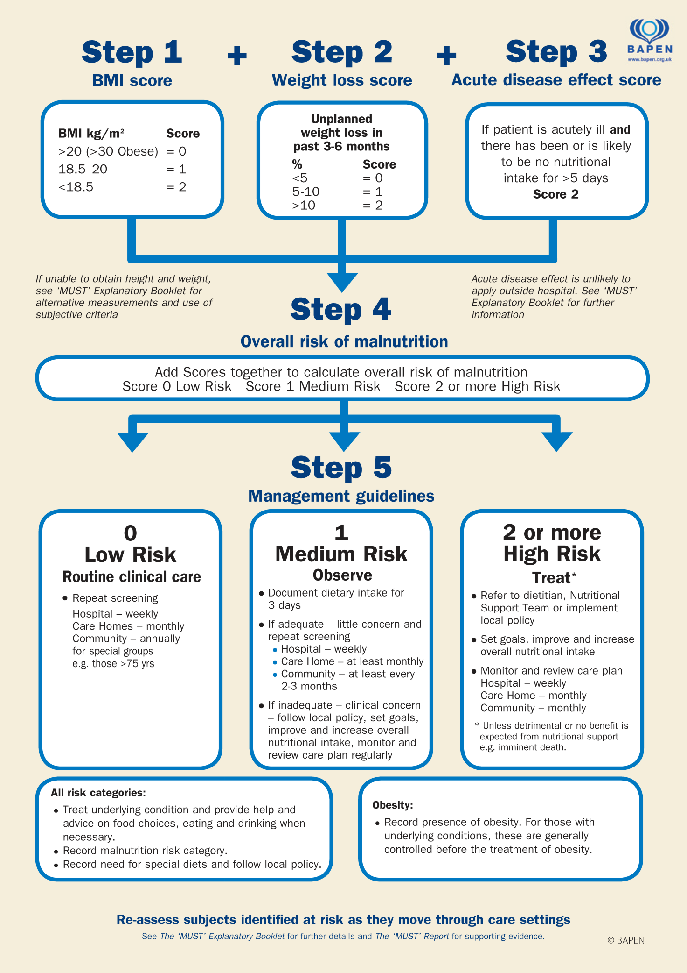

‘MUST’ Calculator: http://www.bapen.org.uk/screening-and-must/must-calculator

‘MUST’ Toolkit: http://www.bapen.org.uk/screening-and-must/must/must-toolkit

