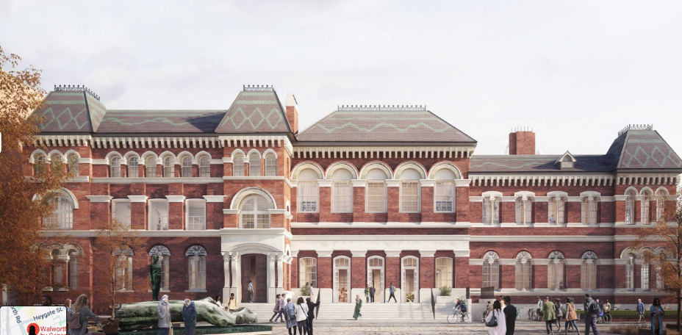
SEL ICB Board Meeting in Public [In-person]
Walworth Town Hall
151 Walworth Rd, London SE17 1RS

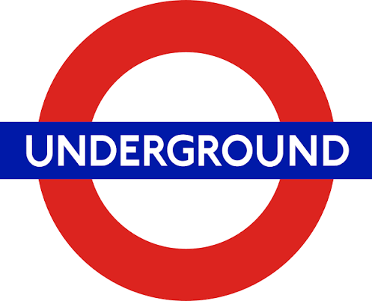
Nearest Stations:
- Elephant & Castle (Northern & Bakerloo Lines) + 6 min walk
- Kennington (Northern line) + 13 min walk
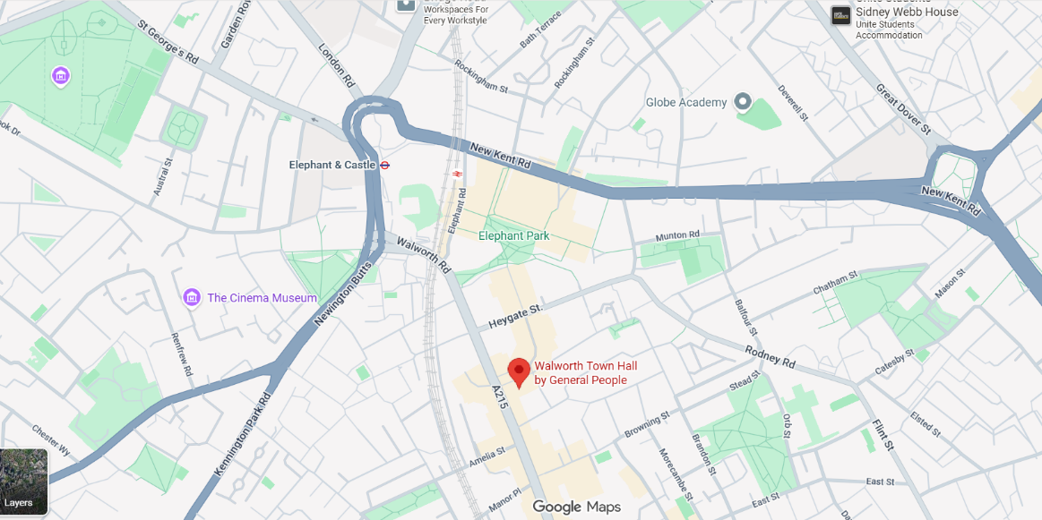
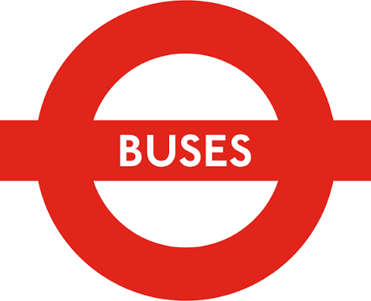
From London Bridge/Tooley Street Bus 343 (towards New Cross Gate)
Get off at Stop R

