Standard Operating Procedure

Management of Quality Alerts (QAs) in South East London Integrated Care Board

DOCUMENT INFORMATION

Approved by | Themes and Concerns Group (TCG)
Approved Date | August 2023
Name and title of originator /author | Dean Francis, Quality Support Manager  Diane Goodenough, Quality Manager  Fiona Leacock, Associate Director of Quality
Name and title of sponsor | Paul Larrisey, Director of Quality
Name of responsible committee | Themes and Concerns Group (TCG)
Review date | August 2026
Target audience | All Staff
Stakeholders engaged in development or review | Governing Body Members with responsibility for Patient Safety and Quality  Directors and Associate Directors of Quality  Heads of Quality  Senior Quality Managers  Senior Quality Lead

Version Control

Version Number | 2
Supersedes | 1.2

Implementation

Implementation plan in place | Yes
Method and date of dissemination | Via email  August 2023

Monitoring

Monitoring method | Audit & Review of reporting
Frequency | Every 3 years
Responsibility | Associate Director of Quality

Document Review Control Information

Version | Date | Reviewer  Name(s) and Job titles | Change/amendment
1.1 | December 2020 | Fiona Leacock/Harpinder Priest | New version
1.2 | January 2020 | Fiona Leacock/Harpinder Priest | Updated with new guidance and feedback
2.0 | July 2023 | Dean Francis /  Diane Goodenough /  Fiona Leacock | CCG merger into ICB  Updated with new guidance

- Statement

  - This procedure sets out the systems, processes, and accountability within South East London Integrated Care Board (SEL ICB) for the management of Quality Alerts (QAs). By adopting this procedure, SEL ICB aims to improve the organisation’s ability to:

- commission high quality, safe and accountable health services,
- minimise risk to patients and members of the public
- share learning from QAs across the South East London Integrated Care System (ICS).

- Introduction

  - As a Commissioner, SEL ICB procures a range of services some of which are large and complex. SEL ICB is committed to complying with legislation and NHS standards that require SEL ICB to have robust systems and processes in place for the management of all QAs.
  - This document applies to QAs reported to the SEL ICB Quality Information Team (QIT), irrespective of incident date.
  - A quality alert (QA) is a concern or a systemic issue generally affecting a service/pathway that affects individual/group of patients and affects the ability to deliver a high-quality service within SEL.

- Purpose

  - The purpose of this procedure is to ensure that all members, staff and/or employees working for or on behalf of the ICB are aware of their duties when reporting, investigating, or managing QAs in relation to commissioned providers. It applies to all QAs whether they involve commissioned services, patients, carers, visitors, staff, or members of the public and include property, premises, assets, information, or any other aspect of the organisations’ business. It gives direction and organisational regulation so that managers are aware of their duties in the approval, management, and investigation of alerts. This procedure aims to:

- Ensure that all QAs are logged, tracked, responded to, and investigated in a timely, efficient, and effective way.
- Ensure compliance with any associated national reporting requirements NHS England » Primary care information on the new national learn from patient safety events service and the ICB’s Patient Safety Strategy Patient Safety Workplan v1.pptx (sharepoint.com).
- A reasonable, proportionate, and consistent approach across the six boroughs within SEL ICB.
- Ensure SEL ICB has an open and honest approach to provider QA reporting and management for QAs affecting patients/relatives/carers, and a commitment to identifying themes and sharing lessons learned from across the ICS.
- Ensure lessons learnt from QAs and trends are shared across SEL ICB and ICS and fully acted upon by commissioned providers.
- Enhance learning and development across the ICS through the application of good quality and performance management principles.

- Responsibilities

  - The Chief Executive Officer -The Chief Executive Officer has responsibility for ensuring SEL ICB has in place robust mechanisms to fulfil its duty of care in reducing harm to patients and ensuring patient safety.
  - The Chief Nurse - The Chief Nurse has responsibility for ensuring SEL ICB has in place systems and processes for monitoring the QA process and for continuous improvement from lessons learnt and where appropriate for commissioning QA themes and learning from investigations.
  - The Quality and Performance Committee - The Quality and Performance Committee (QPC) has responsibility for providing assurance to the ICB Board that organisational learning has occurred.
  - The System Quality Group – The System Quality Group (SQG) has responsibility for identifying actions from key themes that identify opportunities for improvement and concerns/risks to quality and safeguarding and develop system responses to enable ongoing improvement in the quality of care and services across the ICS.
  - The Director of Quality - The Director of Quality has responsibility for ensuring arrangements are in place for managing the process of QAs and that lessons are learnt and shared across SEL ICB.
  - Clinical and Care Professional Leaders (Quality) – The Clinical and Care Professional Leaders [CCPLs] support working together across organisations and professions to improve health inequalities and patient safety in their area. They also have responsibility for the oversight of the associated themes of quality and patient safety and shared learning.
  - The Quality Information Team - The Quality Information Team (QIT) has responsibility for managing the process that ensures that all commissioned providers across SEL ICB are reporting, investigating, and acting on QAs in line with this procedure. These arrangements include the identification, recording, tracking, acknowledgement, monitoring and learning from the implementation of any actions that arise from QAs.

5. Aims

The aims of this procedure outline how QAs will be managed successfully across the SEL ICB. This includes:
- Having a clear system for commissioned care providers to report QAs.
- To acknowledged and prioritise all QAs received and to identify impending quality issues for urgent response and those for thematic tracking.
- Ensuring that providers submitting QAs will receive an acknowledgement advising them how their alert has been graded and the next steps, e.g. included in thematic analysis, individual response due.
- To identify patient safety incidents (LPFSE reportable link: NHS England » Learn from patient safety events (LFPSE) service.
- To ensure no patient identifiable information is shared in line with legislation and information governance regulations applicable to the organisations involved.
- To ensure and collate responses received from providers to QAs and to feedback to the submitting organisation.
- To provide regular reports to all providers including borough-based teams, primary care teams and internal directorates and commissioners as required.

QA Process Management flowchart
The following flowchart depict the process by which QAs will be managed.
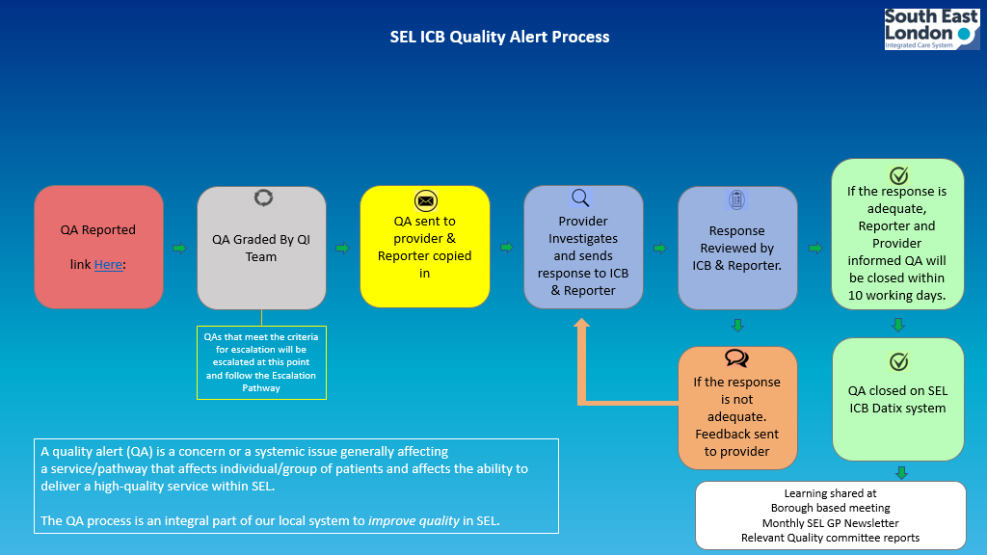

QA Grading Process
The flowchart below depicts the grading of QAs.
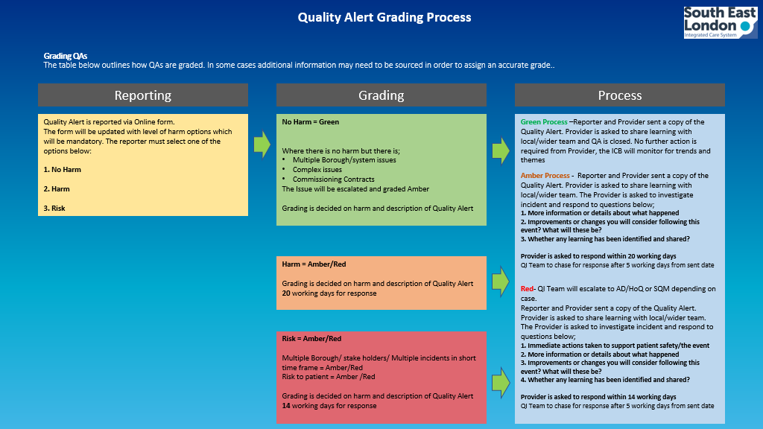
Escalation Process for Patient Safety Events (PSEs), Serious Incidents (SIs) and Quality Alerts (QAs)
The flowchart below shows the escalation process of PSEs, SIs and QAs reported to the ICB.
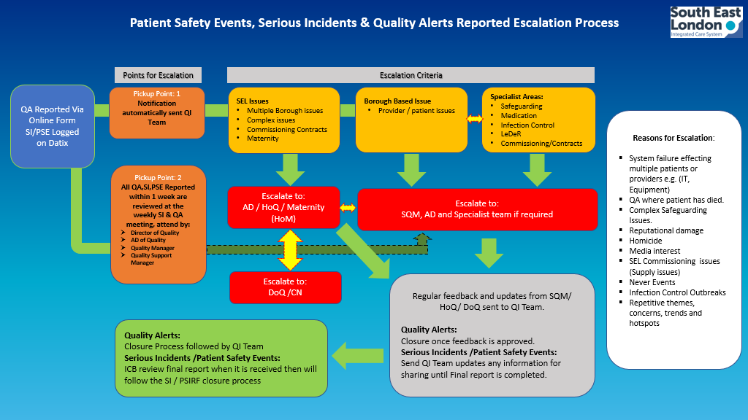
- Duties of organisations commissioned by the ICB to provide health services

  - All service providers commissioned by the ICB, either as a co-ordinating commissioner, community interest company or associate, have a requirement to report, investigate and monitor alerts, incidents (including SIs) and patient safety events (PSEs) as specified within contracts and legislation.

- Dissemination, Training & Advice

  - Once ratified, this procedure will supersede all previous QA reporting policies and procedures. In order that this procedure is disseminated and implemented correctly, the following will occur after ratification:

- The procedure will be published on the SEL ICS website and relevant links (Datix QA reporting here will be sent out via the communications and engagement department.
- The Datix risk management training is designed to match this procedure and attendees will be made aware of this procedure.
- Senior managers will make their staff aware of this procedure
- Advice can be sought from the Quality Information Team (QIT).

- Process for Approval & Ratification

  - This procedure will be approved and ratified by the Quality and Performance Committee.

- Review, Monitoring and Compliance

  - The document will be reviewed every three years unless there is a significant change in legislation or process which requires an urgent change in procedure such as the introduction of Patient Safety Incident Reporting Framework (PSIRF) in 2022 by the NHSE/I or significant internal process changes in the Quality Information Team.
  - Regular monitoring and review will take place to ensure the continued effectiveness of these procedures.

- Being Open - Open communication of QAs where learning has been identified of a patient while receiving healthcare in line with Duty of Candour legislation.

- Duty of Candour – a statutory requirement introduced to ensure health care providers operate in a more open and transparent way. Regulation 20: Duty of candour | Care Quality Commission (cqc.org.uk)

- Serious Incidents - The ICB and all providers commissioned by the CCG will work in line with national requirements set out in the NHS England Serious Incident Framework 2015 serious-incidnt-framwrk-upd.pdf (england.nhs.uk).

- Patient Safety Incident - A QA which is identified as a patient safety alert MUST be reported directly onto the Learn From Patient Safety Events (LFPSE) online via this link NHS England » Learn from patient safety events (LFPSE) service. Healthcare organisations MUST have systems in place to identify and report patient safety incidents, where this is not the case, the Quality Information Team will review the QA or incident identified to ensure that it has been reported on the appropriate system and will share learning and themes.

- Reporting

13.1 The Quality Information Team will be responsible for collating and analysing data for presentation within reports and monitoring of trends. It will be ensured that all QA reports reviewed and presented are appropriately referenced and graded, collated, and monitored to ensure actions are completed in a timely way and risks escalated in the organisation.
Weekly listing reports will be circulated to Place-based directors and relevant team leads within SEL ICB for information. A monthly report will be presented to the Themes and Concerns Panel highlighting trends and issues arising from QAs, alongside the SI report. A quarterly report will be presented to the SEL ICB Quality and Performance Committee. This report will also be provided to organisations within the Integrated Care system.

Appendix 1 - Equality & Equity Impact Assessment Checklist
This is a checklist to ensure relevant equality and equity aspects of proposals have been addressed either in the main body of the document or in a separate equality & equity impact assessment (EEIA)/ equality analysis. It is not a substitute for an EEIA which is required unless it can be shown that a proposal has no capacity to influence equality. The checklist is to enable the procedure lead and the relevant committee to see whether an EEIA is required and to give assurance that the proposals will be legal, fair, and equitable. The word proposal is a generic term for any procedure, procedure or strategy that requires assessment.

 | Challenge questions | Yes/No | What positive or negative impact do you assess there may be
 | Does the proposal affect one group favourably than another on the basis of:
 | - Race | No
 | - Pregnancy and Maternity | No
 | - Sex | No
 | - Gender and Gender Reassignment | No
 | - Marriage or Civil Partnership | No
 | - Religion or belief | No
 | - Sexual orientation (including lesbian, gay, bisexual, and transgender persons) | No
 | - Will the proposal have an impact on lifestyle?  - (e.g. diet and nutrition, exercise, physical activity, substance use, risk taking behaviour, education, and learning) | No
 | - Age | No
 | - Disability (including learning disabilities, physical disability, sensory impairment, and mental health problems) | No
 | Will the proposal have an impact on social environment?  (e.g. social status, employment, social/family support, stress income) | No
 | Will the proposal have an impact on physical environment?  (e.g. living conditions, working conditions, pollution or climate change, accidental injury, public safety, transmission of infectious disease) | No
 | Will the proposal affect access to or experience of services?  (e.g. Health care, Transport, Social Services, Housing Services, Education) | No
 | Procedure Author | Date | Signature
 | Equalities Manager | Date | Signature

