Alt text

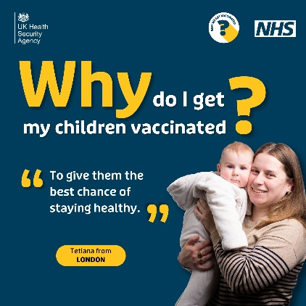 | Image of a European mother holding a baby telling us she got her children vaccinated to give them the best chance of staying healthy.
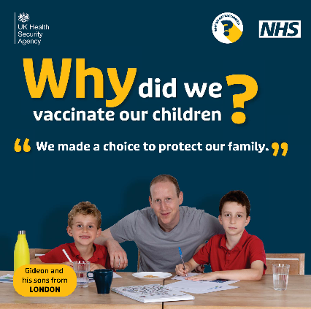 | Image of a European father and sons from London doing homework telling us they got vaccinated to protect their family.
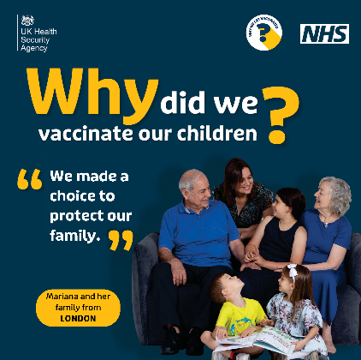 | Image of a European family from London telling us they made the choice to vaccinate to protect their family.
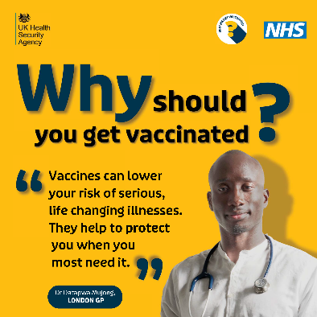 | Image of London GP Dr Datapwa Mujong telling us vaccines can lower the risk of serious, life changing illnesses.
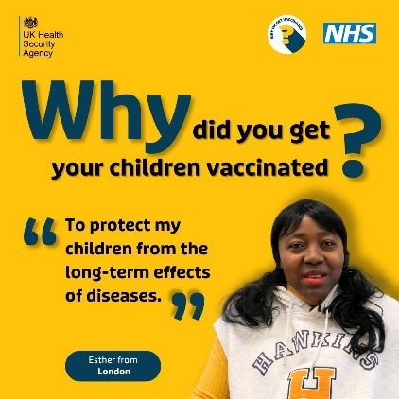 | Image of Black African woman from London telling us she gets her children vaccinated to protect them from the long term effects of diseases.
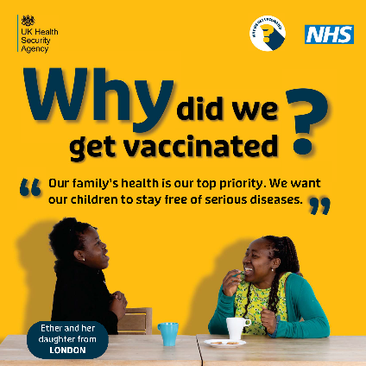 | Image of a Black African mother and daughter from London talking about the choice they made to vaccinate their family.
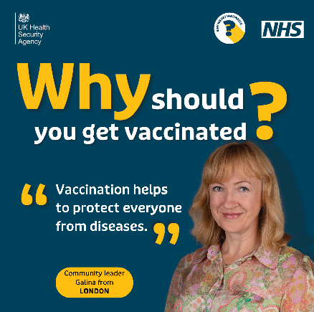 | Image of a community leader from London telling us that vaccinations help protect everyone from diseases.
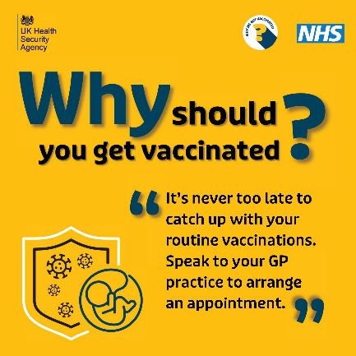 | Image with shield graphic and family icon with text indicating it is never too late to catch up with your routine vaccinations. Just speak to your GP practice to arrange an appointment.
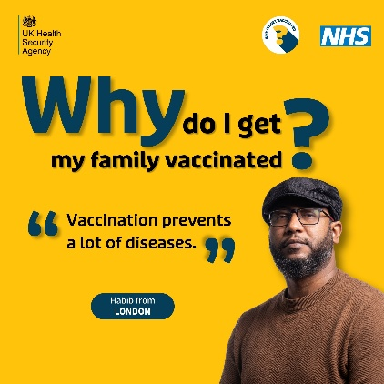 | Image of Black African man from London telling us that he gets his family vaccinated to prevent them from catching diseases.
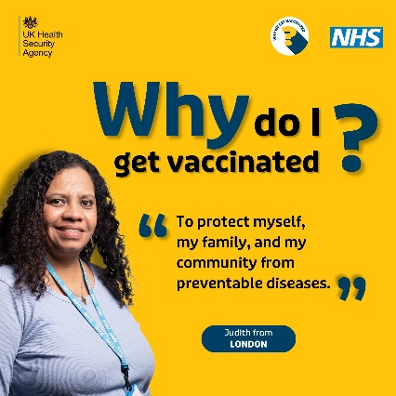 | Image of a Latin American woman from London telling us why she gets vaccinated to protect herself, her family and community from preventable disease.
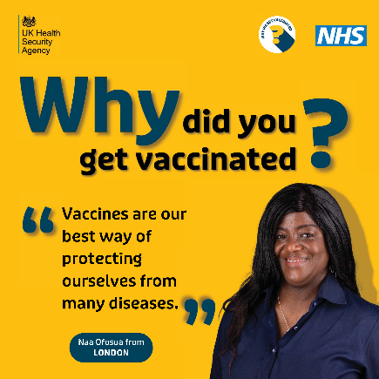 | Image of a Black African woman from London telling us vaccinations are the best way of protecting ourselves from many diseases.
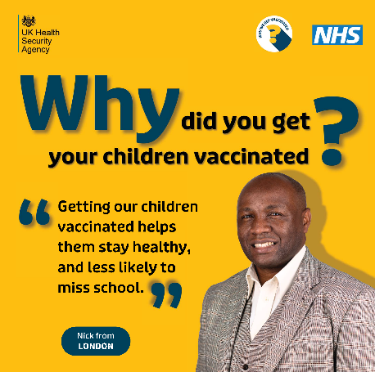 | Image of a Black African father from London telling us that getting his children vaccinated means they are more healthy and less likely to miss school.
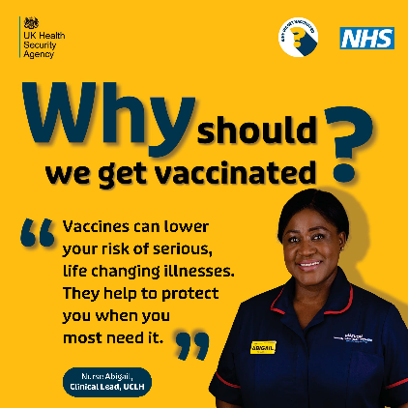 | Image of London nurse Abigail, clinical lead at UCLH, telling us that vaccines can lower your risk of serious, life changing illnesses and help protect you when you most need it.
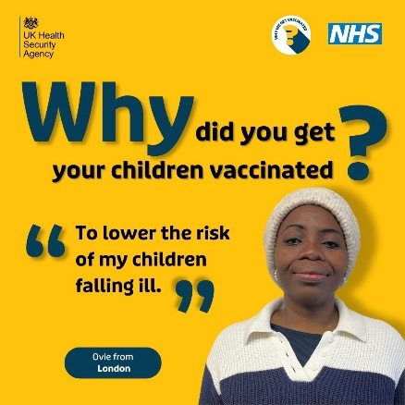 | Image of a Black African woman from London telling us she gets her children vaccinated to lower the risk of them falling ill.
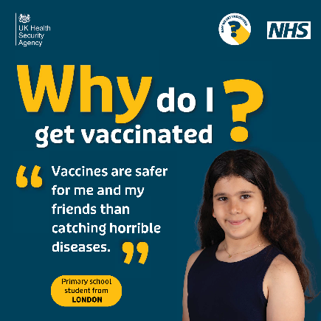 | Image of a primary school child from London telling us she gets vaccinated to make sure she and her friends are safe from catching horrible diseases.
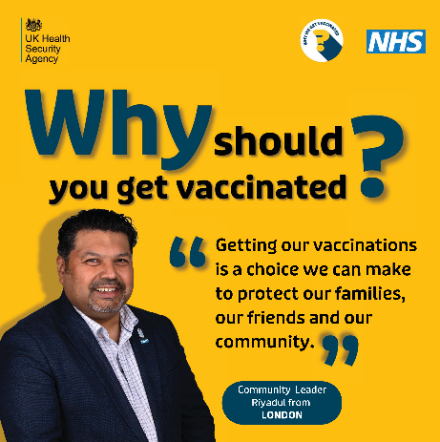 | Image of a community leader from London telling us that vaccinations are a choice we can make to protect our families, friends and communities.
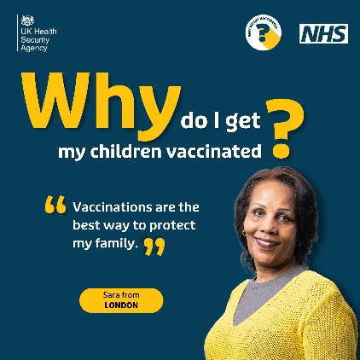 | Image of woman from London telling us she gets her children vaccinated as it’s the best way to keep them protected.
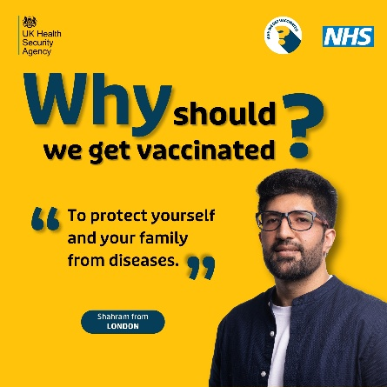 | Image of a man from London telling us we should get vaccinated to protect ourselves and our families from diseases.
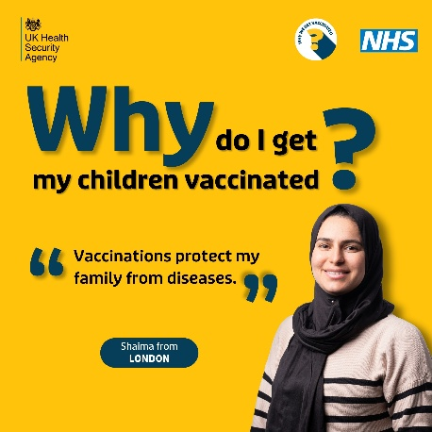 | Image of woman from London telling us she gets her children vaccinated to protect them from diseases.
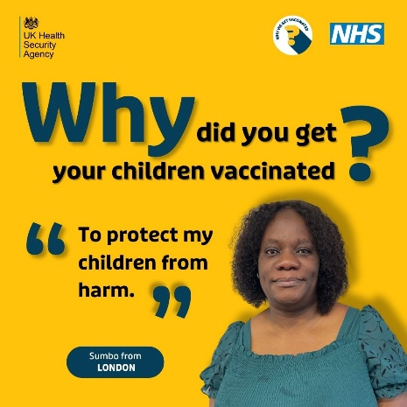 | Image of Black African woman from London telling us she gets her children vaccinated to protect them from harm.
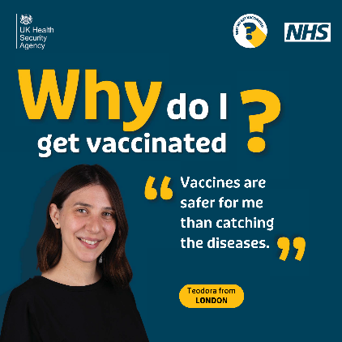 | Image of a young Romanian woman from London telling us vaccinations are safer for her than catch the diseases.
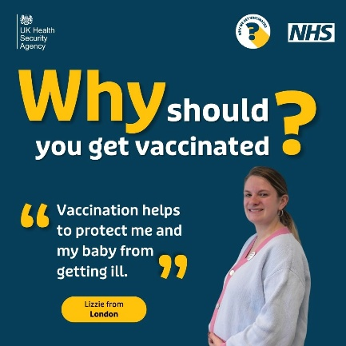 | Image of pregnant woman from London telling us she gets vaccinated to protect herself and her baby from getting ill.
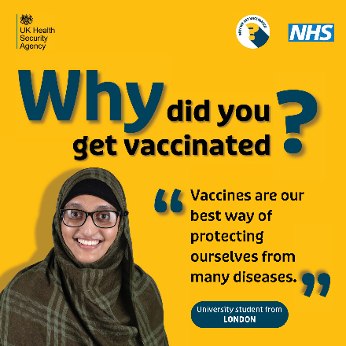 | Image of a student from London telling us vaccinations are the best way of protecting ourselves from many diseases.

